**Summer Enrichment Camp**

**Pre-Registration**

#### 

**Childs Name**

**________________________**

**Age ______**

**Grade for Next School Year**

**__________________________**

**Parent Name**

**___________________________**

**Address _________________________________________________________________________________**

**Phone Number**

**______________________**

**Pre-Register On-line at**

[**www.aspirefoundation16.com**](http://www.aspirefoundation16.com)

**Starting April 24, 2019**

# A.S.P.I.R.E

June 3– July 19, 2019

*Camp will be closed July 1-5

for the Independence Holiday

Grades Pre-K-6th



**Registration Fee: $30 per child**

**Weekly Tuition: $60 per child**

**Space Is Limited. Registration Begins April 24, 2019.**

**Hosted at Williams Chapel C.M.E Church**

**181 Railroad St N, Jeffersonville, GA 31044**

**For More Information, Please call or email**

**Camp Administrator: Tiffany Madison**

**478-918-4956,** [**tiffanysweldon@yahoo.com**](mailto:tiffanysweldon@yahoo.com)

**Camp Director: Shawonda Stephens**

**478-319-4022**

**What We Offer…**

**Highly qualified educators to focus on...**

**Math Skills**

**Reading Skills**

**Writing Skills**

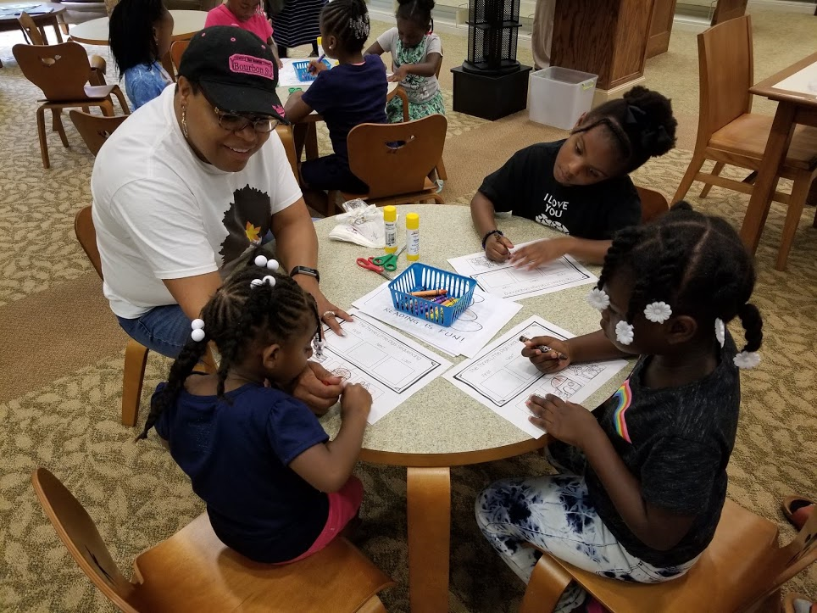

**S.T.E.A.M Projects**

**Science**

**Technology**

**Engineering**

**Artist**

**Math**

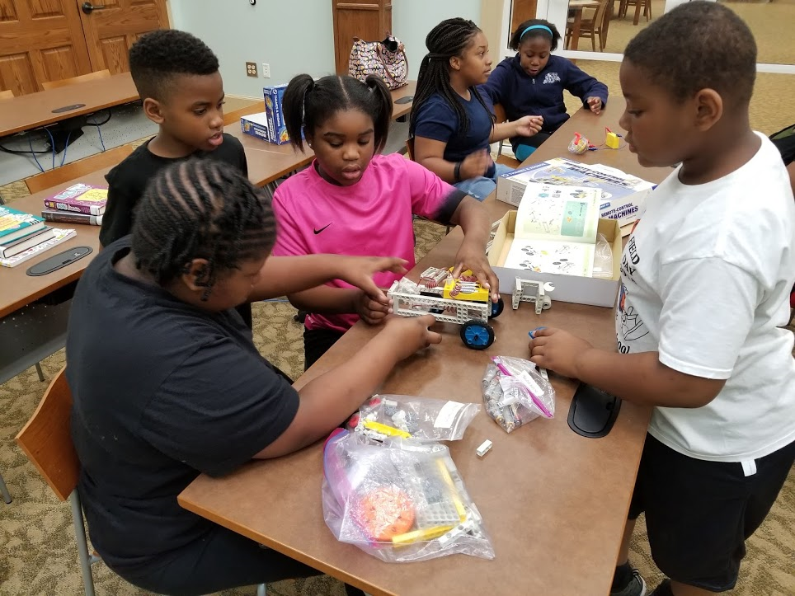

**Character Education**

**Health Education**



**Fun and Educational Field Trip Ideas**

Movie Theater

Tubman Museum

Wild Animal Safari

Bowling

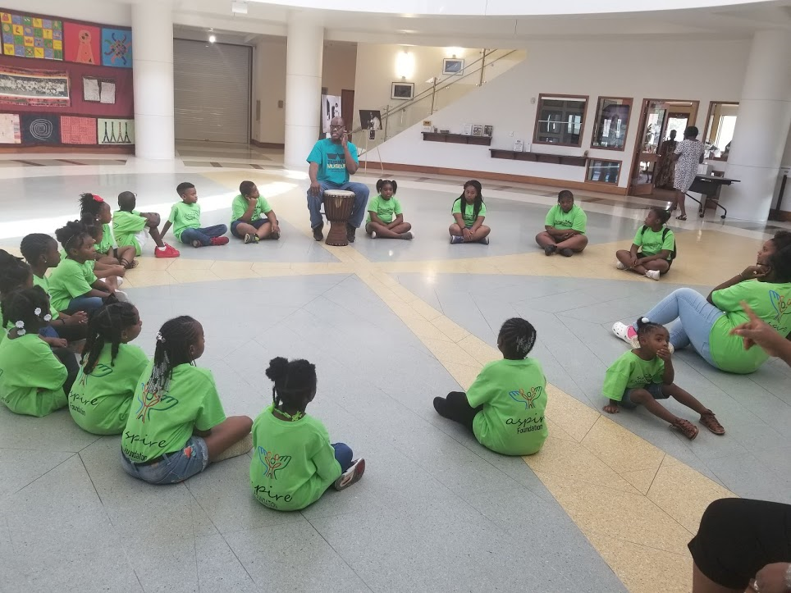

**Delicious and Nutritious Meals**

**Full Breakfast**

**Full Lunch**

**Afternoon Snack**

**From The Director**

**We are so excited about the Summer Enrichment Camp. We are still excited about providing an opportunity for children to expand their minds with stimulating and challenging S.T.E.A.M activities. We will provide fine arts and cultural activities with fun and educational field trips. But more than anything we are excited to provide a place where children are able to keep their minds stimulated through the summer months while school is out. We are ready and willing to help struggling students with Reading, Writing, and Math remediation sessions. Our summer camp will not only prove academic support but physical and character education support as well. We want our campers to be inspired to be healthy, productive, and leaders of good character.**